A000-Pac-Poly-Marquesas-club U’U-Tamanuja wood--early 19th c

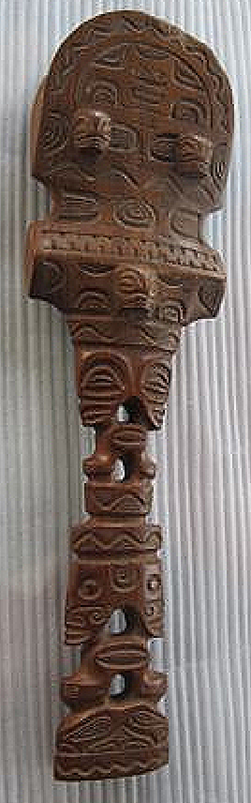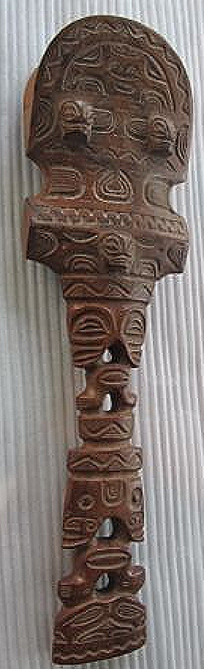

**Case no.: 13**

**Accession Number:**

**Formal Label:** Marquesas-club U’U-early 19th c

**Display Description:**

Carved bifacial club ('u'u) made from tamanuja wood of the Enanta people. Club with heavy, oval-ended head representing a human face. On each side, two small tiki heads carved in high relief, surrounded with radiating lines, represent the eyes. Above the brow line on each side, a small tiki face is carved in low relief, and either side of the eyes also. The main tiki head (representing the nose) is at the centre of a projecting angular crossbar. Below, two rectangular design areas are carved in low relief with the ipu (container) motif, and the two areas are joined by thin arms, the hands raised to the chin of the main tiki. Below this a broad tiki face (eyes, nose and ears only) are carved in low relief, with another band of ipu motifs below. Marquesan men used clubs for fighting and displayed them as symbols of prestige. They were also valued heirlooms; these examples were probably used for as long as two hundred years. Although such clubs initially look very much alike, the designs in the two relief bands below the transverse bar actually show great variety. The motifs used may have been the personal emblems of the man for whom the club was made.

**LC Classification:**

**Date or Time Horizon:**

**Geographical Area:** Nuku Hiva, Marquesa Is.

**Map:**

**GPS coordinates:**

**Cultural Affiliation:** Marquesan

**Medium:** Tamanuja wood

**Dimensions:** H 17 ¾ in75 cm, W  5 in  - 17 cm. According to the owner it was a much longer club - about 52" / 132 cm or so.  He cut it down to fit in his showcase.

**Weight:**

**Condition:**

**Provenance:**

**Discussion:**

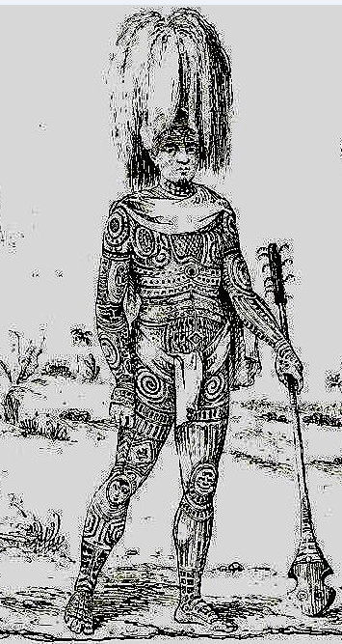

Engraving of a highly tattooed Enata Marquesan with and U’u. After Tenre for Dumont D'Urville, *Voyage Pittoresque Autour Du Monde* (Paris, 1830).

**References:**

Dumont D'Urville, *Voyage Pittoresque Autour Du Monde* (Paris, 1830).

The Metropolitan Museum of Art. *Art of Oceania, Africa, and the Americas from the Museum of Primitive Art*. New York: The Metropolitan Museum of Art, 1969, no. 3.